- Apply relational algebra operations (σ, π, ∪, -, ×, ⋈) on the given
Employee and Department relations to retrieve required records.

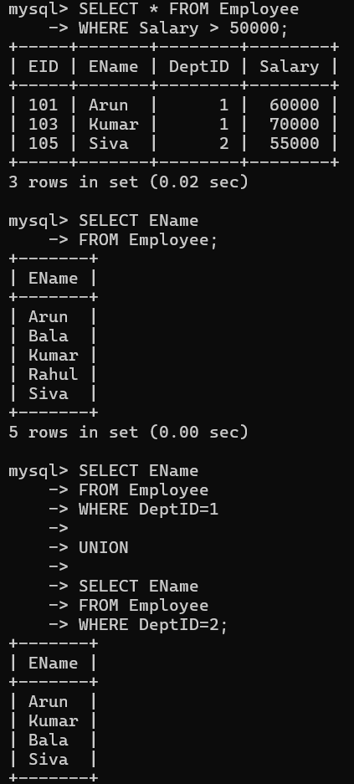

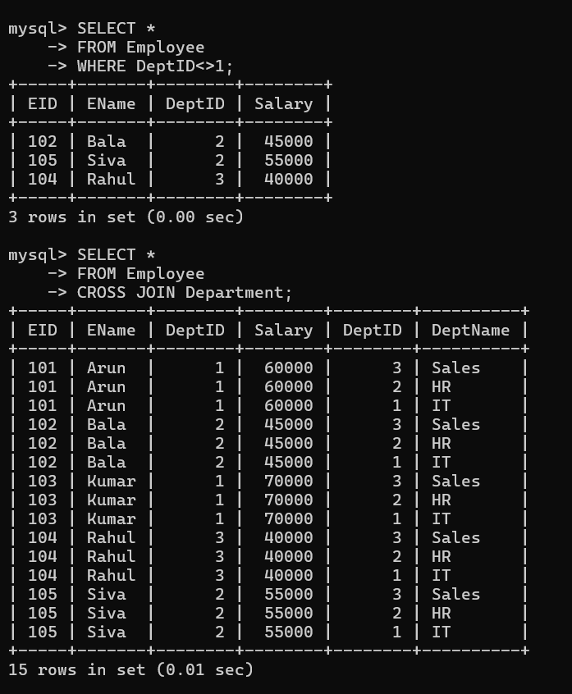

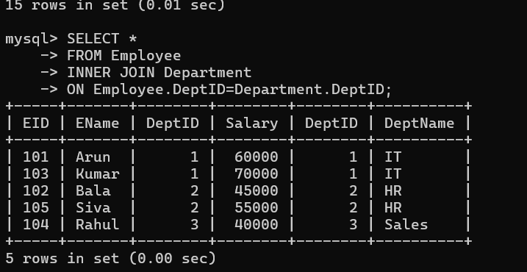

- Write SQL DDL statements to create STUDENT(SID, Name, DOB,
DeptID) and DEPARTMENT(DeptID, DeptName) tables with all
appropriate constraints.

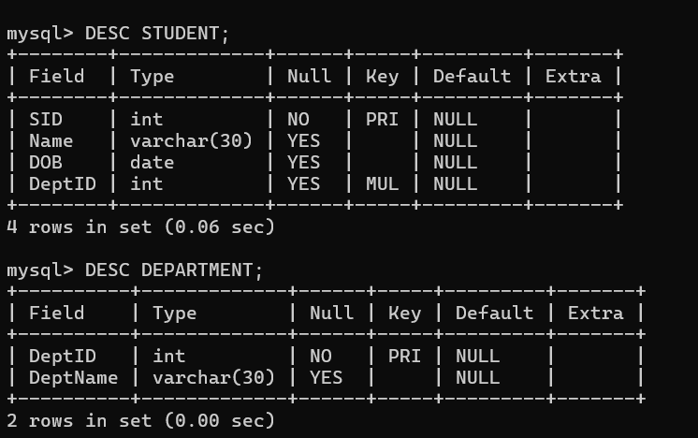

- Formulate SQL queries using GROUP BY, HAVING, and aggregate
functions (COUNT, SUM, AVG, MAX, MIN) on a given Sales
dataset.
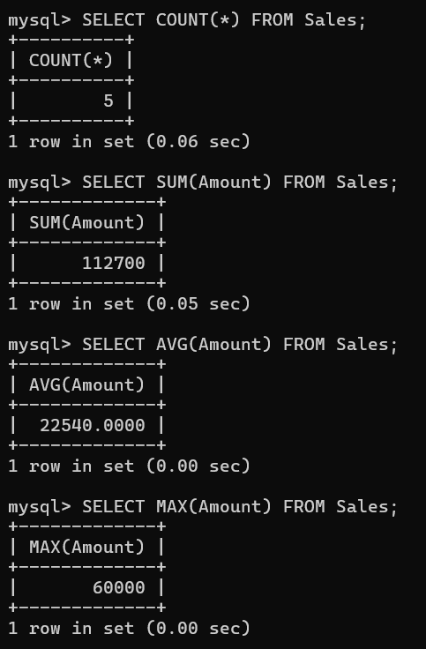

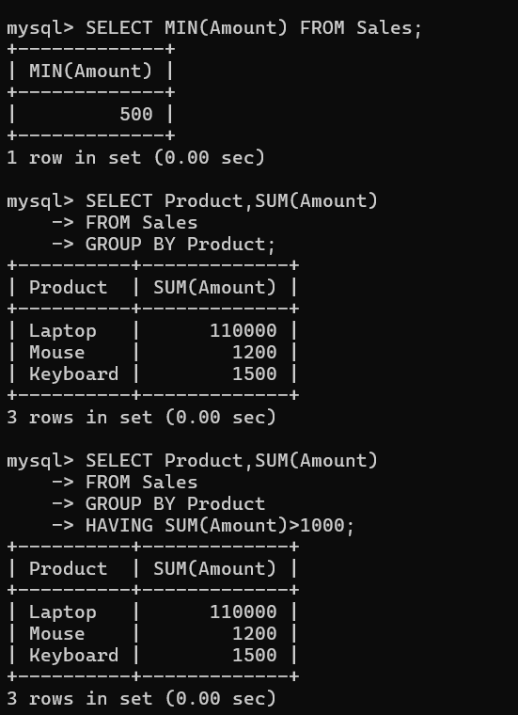

- Write a correlated sub-query to find employees earning more than
the average salary of their own department.

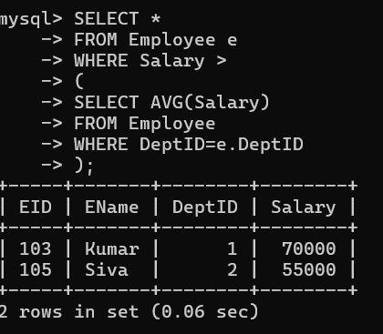

- Apply all types of JOIN operations (INNER, LEFT OUTER, RIGHT
OUTER, FULL OUTER, CROSS) on Employee and Project tables.

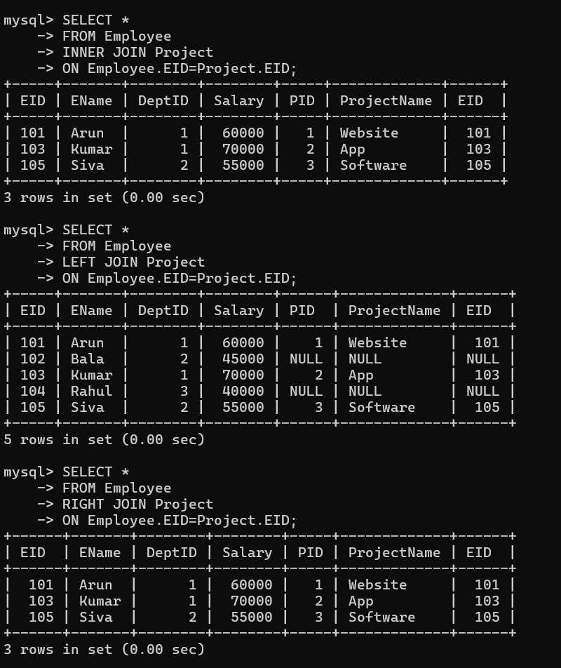

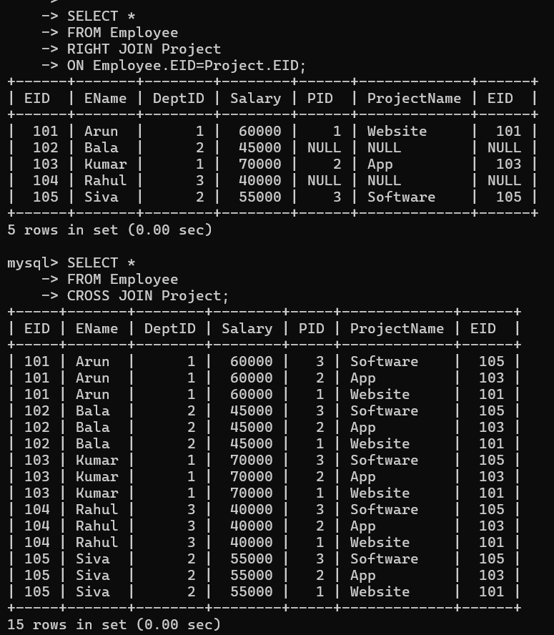

- Create a view &#39;DeptSalaryView&#39; that displays department name,
total employees, and average salary. Write a query on this view.

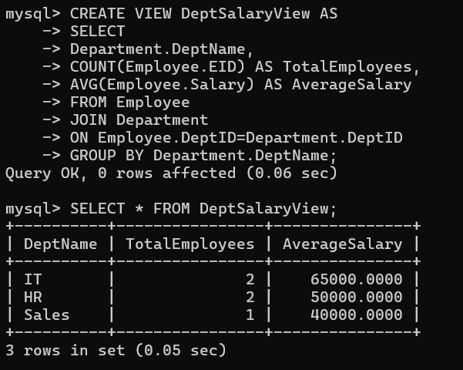

- Write SQL DML statements (INSERT, UPDATE, DELETE) with integrity constraint enforcement for a given scenario.
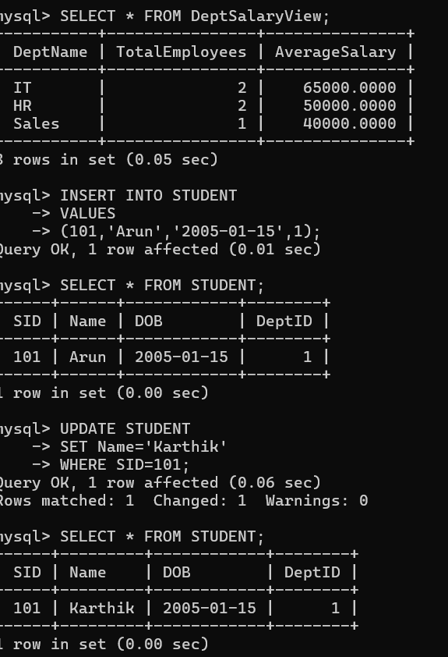

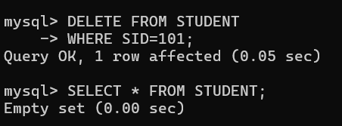

- Apply tuple relational calculus to express a query: Find all
employees who work in the &#39;IT&#39; department and earn more than
50000.
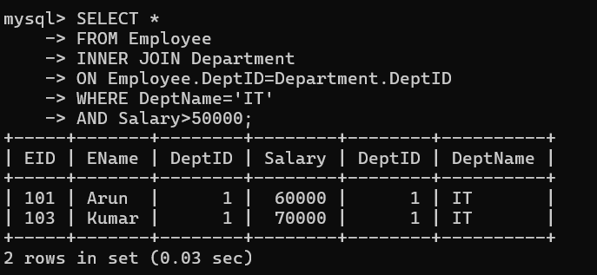

- Design a relational schema for an Airline Reservation System and
write 5 SQL queries demonstrating joins, sub-queries, and views.
